# Artificial Intelligence and Machine Learning

# 1. Introduction

* **Project Title:** CleanTech – Smart Waste Classification and Management System using Transfer Learning
* **Team Members:**

Nagababu Akula (TeamLead)Mahesh Babu PiduguSai Durga Prasad Matta Lakshmi Narayana M

# 2. Project Overview

* **Purpose:** CleanTech is an intelligent platform designed to automate waste classification and management using image recognition powered by transfer learning. It helps municipalities and organizations segregate waste efficiently, reduce manual intervention, and promote environmental sustainability through AI-driven classification and reporting systems.
* **Features:**

1. User registration and login
2. Waste image upload for classification
3. Real-time classification and feedback
4. Automated email/SMS notifications for alerts
5. Intelligent routing to appropriate recycling/processing departments
6. User-admin communication interface
7. Admin dashboard for managing waste categories and classification logs
8. Security: JWT authentication, encrypted file storage, access roles

# 3. Architecture

* **Frontend:**  
  Built using React.js, styled with Material UI and Bootstrap. Axios is used for API calls to the backend. Image upload and classification results are handled through a user-friendly interface.
* **Backend:**  
  Developed using Node.js and Express.js. RESTful APIs manage all frontend requests. Image classification is handled by a Python-based microservice (Flask) integrated via HTTP routes or message queues.
* **Machine Learning Model:**  
  A MobileNetV2 model is fine-tuned with transfer learning to classify waste into predefined categories (plastic, organic, metal, e-waste, etc.). TensorFlow/Keras is used for model training and inference.

# 4. Setup Instructions

**Prerequisites:**

* Node.js (v16 or higher)
* MongoDB (local or Atlas)
* Python 3.8+
* TensorFlow
* Flask
* npm
* .env file with DB URI, API keys, and ML service endpoint

**Installation:**

• git clone https://github.com/your-repo/cleantech.git• cd client && npm install• cd ../server && npm install• cd ../ml_service && pip install -r requirements.txt

# 5. Folder Structure

**Client:**

client/

├── public/

├── src/

│ ├── components/

│ ├── pages/

│ ├── services/

│ └── App.js

**Server:**

# server/

# ├── controllers/

# ├── models/

# ├── routes/

# ├── middleware/

# └── server.js

# 6. Running the Application

**Frontend:**

cd clientnpm start

**Backend:**

cd servernpm start

**9.User Interface**

* **User Dashboard** with waste classification history
* **Image Upload** and classification result display

**10.Testing :**

* Manual testing for user flows
* Postman for API testing
* Unit tests using Jest (backend) and PyTest (ML service)

**11.Screenshots or Demo**

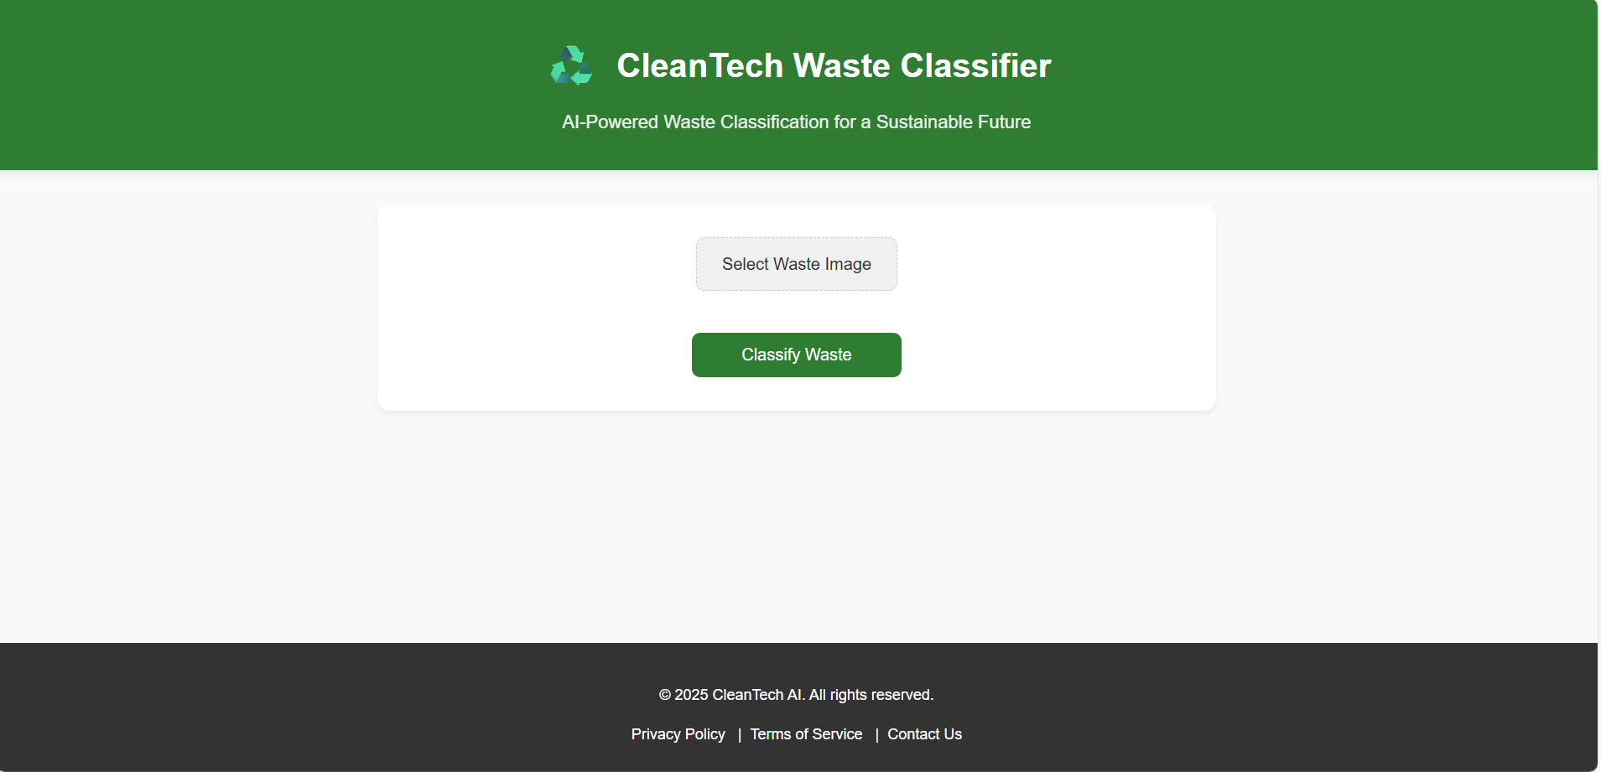.

**12.Known Issues :**

# • Initial model may misclassify overlapping materials• Delay in response from Flask ML service under load• No image preprocessing pipeline yet for low-light or blurry images

# 13. Future Enhancements

* Mobile app using React Native
* On-device lightweight model for offline classification
* AI-based recommendation for disposal or recycling
* Admin analytics dashboard with visual reports
* Multilingual support for regional users